Prestige GYMNASTICS
Mini Olympics 2017

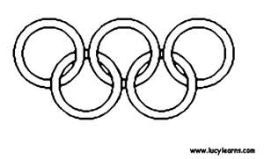
Sunday, April 23rd
11:00 AM
$35.00

Complete the form below and return it with a check
attached for $35.00 no later than April 1st!

A fun-tastic, up-close video moment for family & friends!
A great time for gymnasts to show what they’ve learned.

PRESTIGE’S 2017 MINI OLYMPICS
April 23rd at 11:00 AM

Name:__________________________________________________________
Class Day:________________________________ Time:__________________
Instructor:________________________________ Age:___________________

Circle one: P/tot Pre Kinder Beg 5-7 Beg 8+ Adv 5-7 Adv 8+

Boys Beg Boy Adv

Participant T-shirt size (circle one):
Guaranteed if form is turned in by April 1, 2017
child small child medium child large adult small adult medium

